Q&A: AIS, BABA & BIL Requirements for SRF Funding

Q: What is the AIS requirement?
A: The American Iron & Steel (AIS) requirement applies to all SRF funded construction projects. To meet this requirement, the borrower agrees to use domestically made iron and steel products to construct their project.
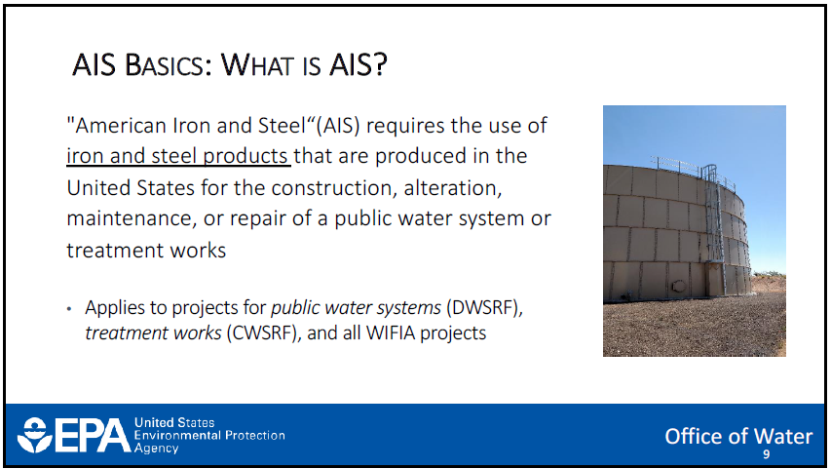

Q: What is the BABA requirement?
A: The Build America, Buy America (BABA) requirement is a provision of the Bipartisan Infrastructure Law (BIL) and it applies to a select group of SRF funded construction projects. To meet this requirement, the borrower agrees to use domestically made iron and steel products, construction materials and manufactured goods. The intent is to go beyond iron and steel to encompass the majority of materials used during construction of the project.
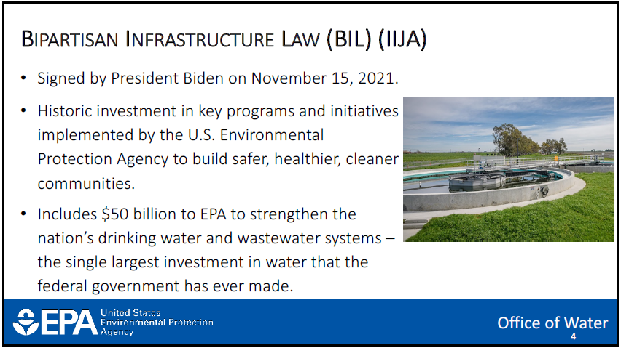
Q: What is the BIL signage requirement?
The BIL signage term and condition requires a physical sign displaying the official Building a Better America emblem and EPA logo be placed at construction sites for BIL-funded projects. For the Clean Water and Drinking Water SRF programs, this requirement applies only to the following projects:
• Construction projects identified as “equivalency projects” for BIL general supplemental capitalization grants;
• Construction projects that receive additional subsidization (grants or forgivable loans) made available by BIL general supplemental capitalization grants;
• All construction projects funded with BIL emerging contaminants capitalization grants;
• All construction projects funded with BIL lead service line replacement capitalization grants.
Specific sign requirements can be found here: https://www.epa.gov/invest/investing-america-signage
Q: Which requirements will apply to each project?
A: The SRF receives funding from a variety of sources. The specific funding source determines which requirements must be met. The SRF team will choose a funding source to be designated based on the project type and other indicators that help us provide the most affordable option to our borrowers. You can learn more about this in our Intended Use Plans, located here:
https://www.iowasrf.com/
The table below identifies the different funding sources we use and what requirements must be met for each one.
AIS, BABA & BIL Signage Requirements by Funding Category
SRF Funding Category | AIS | BABA | BIL SIGNAGE
* CWSRF Base | X | Select Projects | N/A
* DWSRF Base | X | Select Projects | N/A
* CW BIL General Supplemental | X | Select Projects | Select Projects
* DW BIL General Supplemental | X | Select Projects | Select Projects
CW BIL PFAS/Emerging Contaminants | N/A | X | X
DW BIL PFAS/Emerging Contaminants | N/A | X | X
DW BIL Lead Service Line Replacement (LSLR) | N/A | X | X
X = All SRF funded projects within this category must comply with the listed requirement
* Not all projects within this category of funding will be subject to BABA and/or BIL requirements. It will only apply to projects selected to receive loans or loan forgiveness directly from the federal capitalization grant or BIL funds.

Q: How will I know if my project has to comply with BABA or BIL signage?
A: All SRF construction projects must comply with the AIS requirement unless they are specifically matched with a BABA/BIL funding source. You can assume that your project will have to comply with AIS unless you hear otherwise from us. We will identify projects that need to comply with BABA or BIL signage early in their project process. Well before it is time to bid the project, we will inform applicants of the requirements they will have to meet. The SRF Project Compliance Specialist will reach out directly to each borrower to provide documentation and guidance. You can also contact her with questions at amy.seyffer@dnr.iowa.gov or 515-321-7844.
Q: What if my project is using more than one federal funding source?
A: The BABA requirement applies to several federal agencies that provide funding for water infrastructure projects. However, the BABA requirement is not implemented or met in the same way for all agencies. Some agencies have to apply BABA to all of the projects they fund rather than a select few. An SRF project that is only subject to AIS may also be subject to BABA if another funding source such as CDBG or USDA is used. Be sure to contact each funding source to determine if the BABA requirement will apply to your project.
In this situation, BABA supersedes AIS. Similar to AIS, BABA requires the use domestically made iron and steel products. Therefore, duplicate certification letters will not be required. We will accept BABA certification letters for iron and steel projects in lieu of AIS cert letters.
Q: Under the BABA requirement, what happens if my project is underway and a domestic source cannot be found for a product that is needed?
A: Request assistance early and often! EPA has a process in place to assist our borrowers with meeting any challenges that may arise. They offer project and product waivers on a case by case basis.
Contact amy.seyffer@dnr.iowa.gov for assistance with any challenges you encounter when attempting to meet the BABA requirement.
More information can be found here:
www.iowasrf.com
https://www.epa.gov/cwsrf/state-revolving-fund-american-iron-and-steel-ais-requirement
www.epa.gov/cwsrf/build-america-buy-america-baba
Additional questions, contact Amy Seyffer:
Amy.seyffer@dnr.iowa.gov, 515-321-7844

